API RESULTADOS Y EVIDENCIAS
Nombre de trabajo: Pruebas sobre una API pública
Tester: Maria Celeste Paredes

ID: API-01
Método: GET
Endpoint: /products/1
Descripción: Listar solo producto 1
Estructura del JSON:
{
"id": 1,
"title": "Fjallraven - Foldsack No. 1 Backpack, Fits 15 Laptops",
"price": 109.95,
"description": "Your perfect pack for everyday use and walks in the forest. Stash your laptop (up to 15 inches) in the padded sleeve, your everyday",
"category": "men's clothing",
"image": "https://fakestoreapi.com/img/81fPKd-2AYL._AC_SL1500_t.png",
"rating": {
"rate": 3.9,
"count": 120
}
EVIDENCIA O1
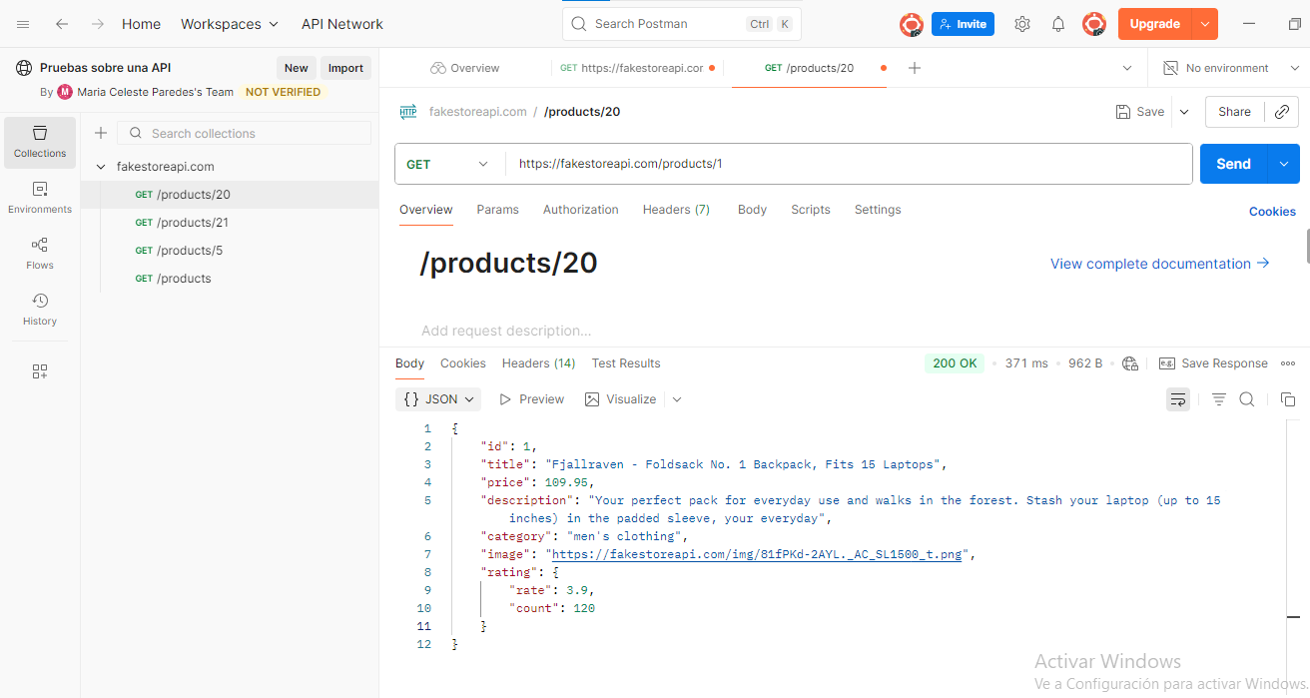
ID: API-02
Método: GET
Endpoint: /products/20
Descripción: Listar solo producto 20
Estructura del JSON:
{
"id": 20,
"title": "DANVOUY Womens T Shirt Casual Cotton Short",
"price": 12.99,
"description": "95%Cotton,5%Spandex, Features: Casual, Short Sleeve, Letter Print,V-Neck,Fashion Tees, The fabric is soft and has some stretch., Occasion: Casual/Office/Beach/School/Home/Street. Season: Spring,Summer,Autumn,Winter.",
"category": "women's clothing",
"image": "https://fakestoreapi.com/img/61pHAEJ4NML._AC_UX679_t.png",
"rating": {
"rate": 3.6,
"count": 145
}
}
EVIDENCIA O2
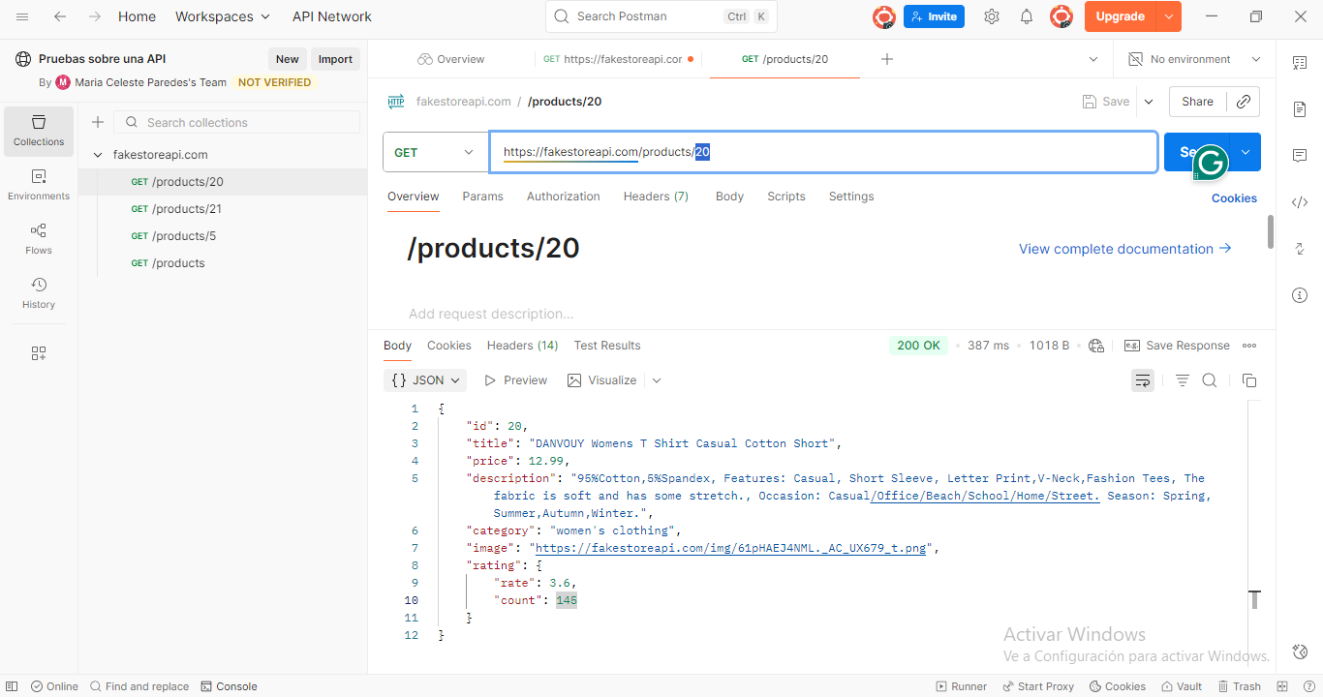

ID: API-03
Método: POST
Endpoint: /products
Descripción: Crear un nuevo producto
Estructura del JSON:
{
"id": 21,
"title": "Womens T Shirt",
"price": 99,
"description": "Has some stretch., Occasion: Casual/Office/Beach/School/Home/Street. Season: Spring,Summer,Autumn,Winter.",
"category": "women's clothing",
"image": "https://fakestoreapi.com/img/61pHAEJ4NML._AC_UX679_t.png",
"rating": {
"rate": 3.4,
"count": 150
}
}
EVIDENCIA O3
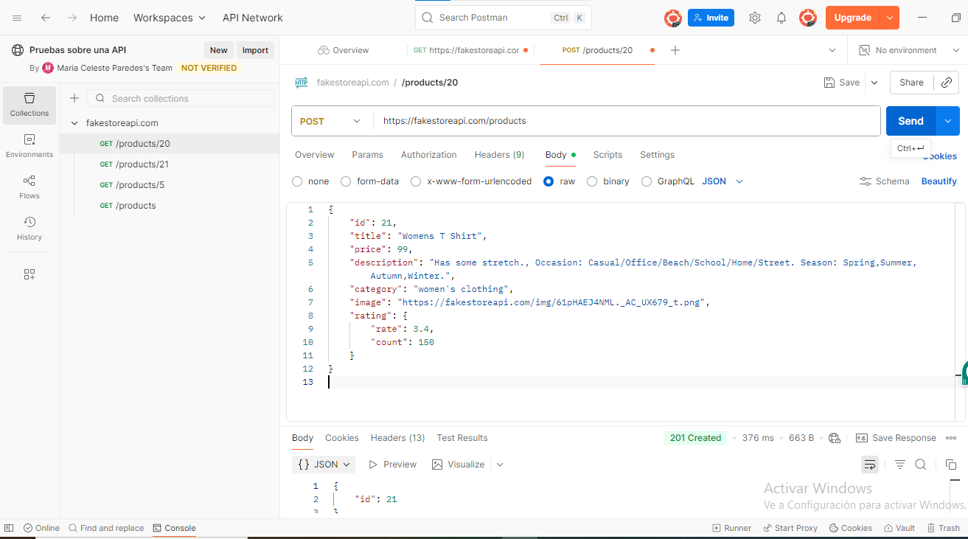
SENT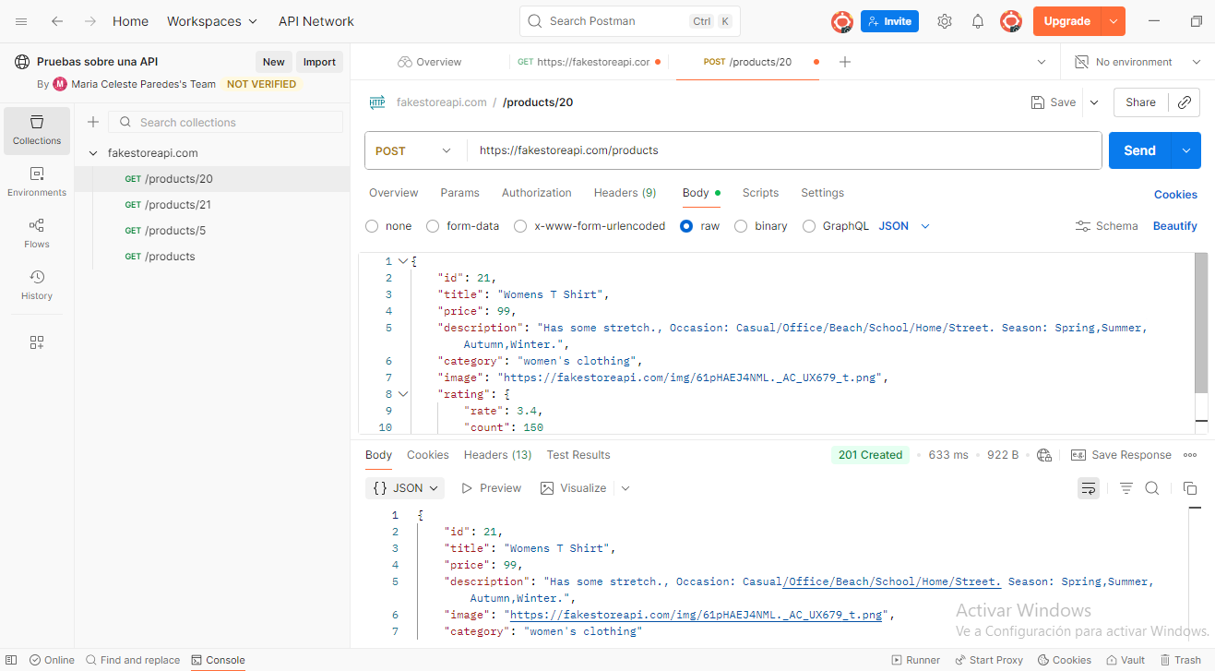

ID: API-04
Método: PUT
Endpoint: /products/7
Descripción: Actualizar un producto existente
Estructura del JSON:
{
"id": 7,
"title": "Womens Shirt",
"price": 50,
"description": "stretch.Season: Spring,Summer,Autumn,Winter.",
"category": "women's clothing",
"image": "https://fakestoreapi.com/img/61pHAEJ4NML._AC_UX679_t.png",
"rating": {
"rate": 4,
"count": 5
}

EVIDENCIA O4

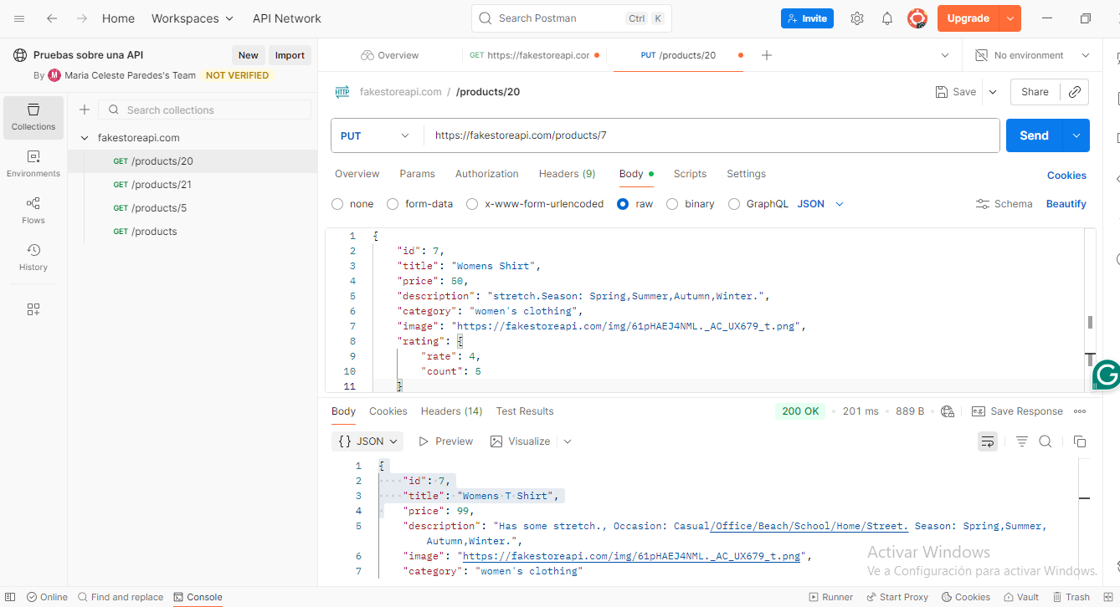

Resultado:
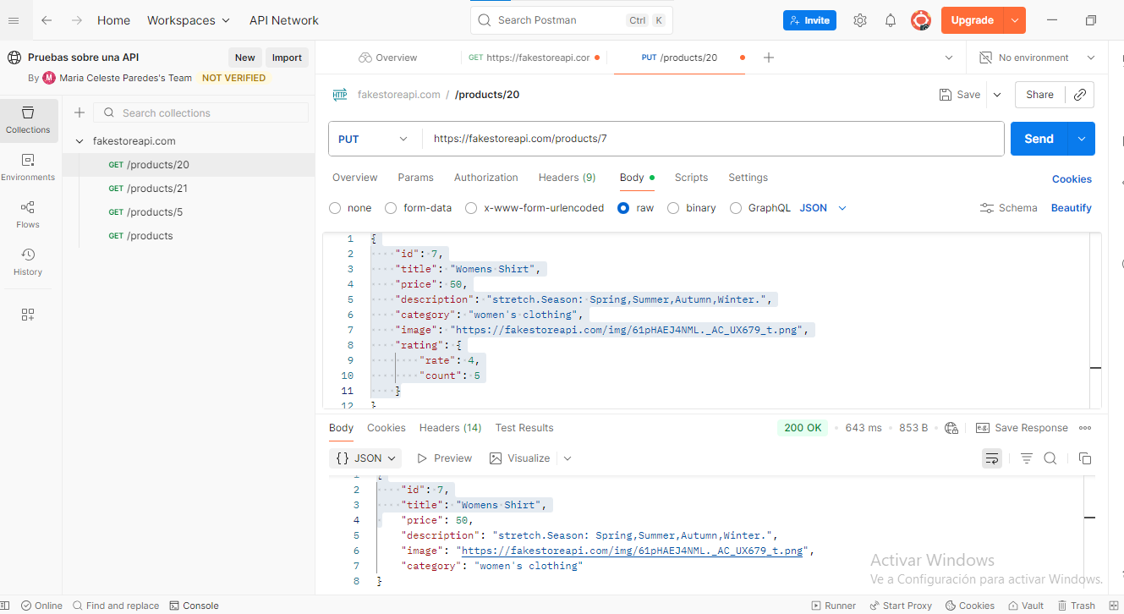

ID: API-05
Método: GET
Endpoint: /products/9999
Descripción: Recurso Inexistente (Caso Negativo)
Estructura del JSON: VACIO

EVIDENCIA O5
En escritorio
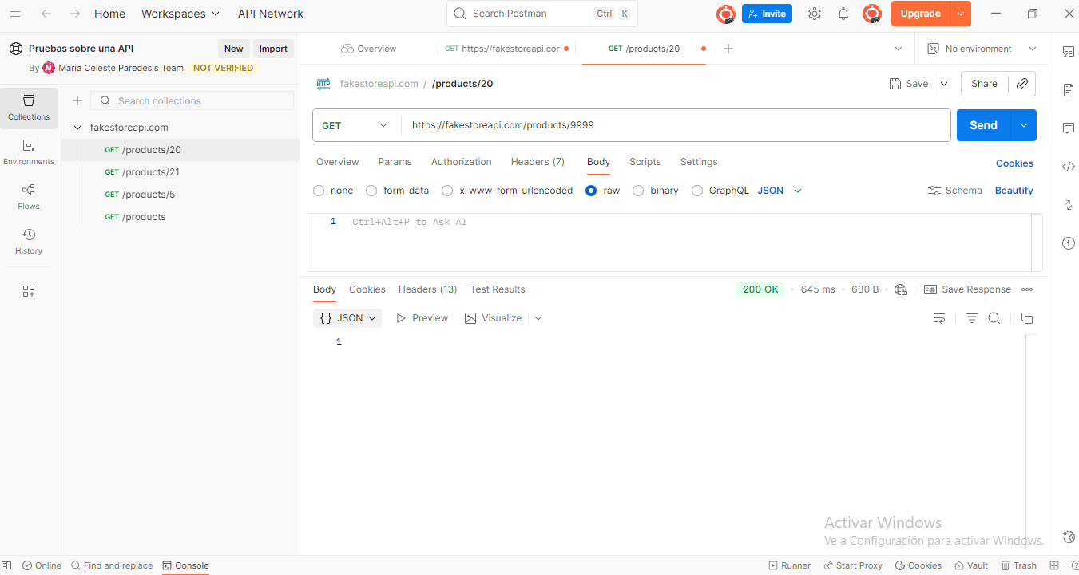
ID: API-06
Método: GET
Endpoint: /products/10
Descripción: Validación de Estructura JSON
Estructura del JSON:
{
"id": 10,
"title": "SanDisk SSD PLUS 1TB Internal SSD - SATA III 6 Gb/s",
"price": 109,
"description": "Easy upgrade for faster boot up, shutdown, application load and response (As compared to 5400 RPM SATA 2.5” hard drive; Based on published specifications and internal benchmarking tests using PCMark vantage scores) Boosts burst write performance, making it ideal for typical PC workloads The perfect balance of performance and reliability Read/write speeds of up to 535MB/s/450MB/s (Based on internal testing; Performance may vary depending upon drive capacity, host device, OS and application.)",
"category": "electronics",
"image": "https://fakestoreapi.com/img/61U7T1koQqL._AC_SX679_t.png",
"rating": {
"rate": 2.9,
"count": 470
}
}

EVIDENCIA O6
